TEAM5OARS

SE Team Project with Line Numbers
TEXTUAL ANALYSIS for
OOA Workflow
UML MVC CLASS DIAGRAM

Version 2.0

# of Classes: 11

Table of Classes:

Class # | Class Name | MVC ?
1 | Staff | Yes
2 | Apartment | Yes
3 | Tenant | Yes
4 | Tenant_Auto | Yes
5 | Rental | Yes
6 | Rental_Invoice | Yes
7 | Complaints | Yes
8 | Testimonials | Yes
9 | Controller | Yes
10 | View | Yes
11 | TEAM5OARS | Yes

# of Attributes: 61_

Table of Attributes:

Class Name | Attribute # | Attribute Name
Staff | 1 | first_name
Staff | 2 | last_name
Staff | 3 | position
Staff | 4 | gender
Staff | 5 | dob
Staff | 6 | salary
Staff | 7 | username
Staff | 8 | password
Staff | 9 | staff_no
Apartment | 1 | apt_no
Apartment | 2 | apt_type
Apartment | 3 | apt_status
Apartment | 4 | apt_utility
Apartment | 5 | apt_deposit_amt
Apartment | 6 | apt_rent_amt
Tenant | 1 | tenant_ss
Tenant | 2 | tenant_name
Tenant | 3 | tenant_dob
Tenant | 4 | martial
Tenant | 5 | work_phone
Tenant | 6 | home_phone
Tenant | 7 | employer
Tenant | 8 | gender
Tenant | 9 | username
Tenant | 10 | password
Tenant_Auto | 1 | license_no
Tenant_Auto | 2 | auto_make
Tenant_Auto | 3 | auto_model
Tenant_Auto | 4 | auto_year
Tenant_Auto | 5 | auto_color
Tenant_Family | 1 | family_ss
Tenant_Family | 2 | name
Tenant_Family | 3 | spouse
Tenant_Family | 4 | child
Tenant_Family | 5 | divorced
Tenant_Family | 6 | single
Tenant_Family | 7 | gender
Tenant_Family | 8 | dob
Rental | 1 | rental_no
Rental | 2 | rental_date
Rental | 3 | rental_status
Rental | 4 | cancel_date
Rental | 5 | lease_type
Rental | 6 | lease_start
Rental | 7 | lease_end
Rental | 8 | renewal_date
Rental_Invoice | 1 | invoice_no
Rental_Invoice | 2 | invoice_date
Rental_Invoice | 3 | invoice_due
Rental_Invoice | 4 | cc_no
Rental_Invoice | 5 | cc_type
Rental_Invoice | 6 | cc_exp_date
Rental_Invoice | 7 | cc_amt
Complaints | 1 | complaint_no
Complaints | 2 | complaint_date
Complaints | 3 | rental_complaint
Complaints | 4 | apt_complaint
Complaints | 5 | status
Testimonials | 1 | testimonial_id
Testimonials | 2 | testimonial_date
Testimonials | 3 | testimonial_context

# of Methods : 141

Table of Methods:

Class Name | Method # | Method Name + Params
Staff | 1 | Staff()
Staff | 2 | getStaff_No() String;
Staff | 3 | setStaff_No(String new_staff_no):void
Staff | 4 | getFirst_Name():String
Staff | 5 | setFirst_Name(String new_first_name):void
Staff | 6 | getLast_Name():String
Staff | 7 | setLast_Name(String new_last_name):void
Staff | 8 | getPosition():String
Staff | 9 | setPosition(String new_position):void
Staff | 10 | getGender():char
Staff | 11 | getDOB():String
Staff | 12 | setDOB(String new_dob):void
Staff | 13 | setGender(char new_gender):void
Staff | 14 | getSalary():int
Staff | 15 | setSalary(int new_salary):void
Staff | 16 | getUsername():String
Staff | 17 | setUsername(String new_username):void
Staff | 18 | getPassword():String
Staff | 19 | setPassword(String new_password):void
Apartment | 1 | getAptNo(): int
Apartment | 2 | setApt_No(int apt_no): void
Apartment | 3 | getAptType():
Apartment | 4 | setApt_Type(int apt_type): void
Apartment | 5 | getApt_Status(): char
Apartment | 6 | setApt_Status(char apt_status): void
Apartment | 7 | getApt_Utility(): char
Apartment | 8 | setApt_Utility(char apt_utility): void
Apartment | 9 | getApt_Deposit_Amt(): int
Apartment | 10 | setApt_Deposit_Amt(int apt_deposit_amt): void
Apartment | 11 | getApt_Rent_Amt(): int
Apartment | 12 | setApt_Rent_Amt(int apt_rent_amt): void
Tenant | 1 | getTenant_SS(): int
Tenant | 2 | setTenant_SS(int tenant_ss): void
Tenant | 3 | getTenant_Name(): String
Tenant | 4 | setTenant_Name(String tenant_name): void
Tenant | 5 | getTenant_DOB(): String
Tenant | 6 | setTenant_DOB(String tenant_dob): void
Tenant | 7 | getMarital(): char
Tenant | 8 | setMarital(char marital): void
Tenant | 9 | getWork_Phone(): int
Tenant | 10 | setWork_Phone(int work_phone): void
Tenant | 11 | getHome_Phone(): int
Tenant | 12 | setHome_Phone(int home_phone): void
Tenant | 13 | getEmployer(): String
Tenant | 14 | setEmployer(String employer): void
Tenant | 15 | getGender(): char
Tenant | 16 | setGender(char gender): void
Tenant | 17 | getUsername(): String
Tenant | 18 | setUsername(String username): void
Tenant | 19 | getPassword(): String
Tenant | 20 | setPassword(String password): void
Tenant | 21 | displayTenantInfo(): void
Tenant | 22 | viewRentalAgreement(): void
Tenant_Auto | 1 | getLicenseNo(): String
Tenant_Auto | 2 | setLicense_No(String license_no): void
Tenant_Auto | 3 | getAuto_Make(): String
Tenant_Auto | 4 | setAuto_Make(String auto_make): void
Tenant_Auto | 5 | getAuto_Model(): String
Tenant_Auto | 6 | setAuto_Model(String auto_model): void
Tenant_Auto | 7 | getAuto_Year(): int
Tenant_Auto | 8 | setAuto_Year(int auto_year): void
Tenant_Auto | 9 | getAuto_Color(): String
Tenant_Auto | 10 | setAuto_Color(String auto_color): void
Tenant_Family | 1 | getFamily_SS(): int
Tenant_Family | 2 | setFamily_SS(int family_ss): void
Tenant_Family | 3 | getName(): String
Tenant_Family | 4 | setName(String name): void
Tenant_Family | 5 | getSpouse(): char
Tenant_Family | 6 | setSpouse(char spouse): void
Tenant_Family | 7 | getChild(): char
Tenant_Family | 8 | setChild(char child): void
Tenant_Family | 9 | getDivorced(): char
Tenant_Family | 10 | setDivorced(char divorced): void
Tenant_Family | 11 | getSingle(): char
Tenant_Family | 12 | setSingle(char single): void
Tenant_Family | 13 | getGender(): char
Tenant_Family | 14 | setGender(char gender): void
Tenant_Family | 15 | getDOB(): String getDOB(): String
Tenant_Family | 16 | setDOB(String dob): void
Rental | 1 | getRental_No(): int
Rental | 2 | setRental_No(int rental_no): void
Rental | 3 | getRental_Date(): String
Rental | 4 | setRental_Date(String rental_date): void
Rental | 5 | getRental_Status(): char
Rental | 6 | setRental_Status(char rental_status): void
Rental | 7 | getCancel_Date(): String
Rental | 8 | setCancel_Date(String cancel_date): void
Rental | 9 | getLease_Type(): String
Rental | 10 | setLease_Type(String lease_type): void
Rental | 11 | getLease_Start(): String
Rental | 12 | setLease_Start(set lease_start): void
Rental | 13 | getLease_End(): String
Rental | 14 | setLease_End(String lease_end): void
Rental | 15 | getRenewal_Date(): String
Rental | 16 | setRenewal_Date(String renewal_date): void
Rental_Invoice | 1 | getInvoiceNo(): int
Rental_Invoice | 2 | setInvoice_No(int invoice_no): void
Rental_Invoice | 3 | getInvoice_Date(): String
Rental_Invoice | 4 | setInvoice_Date(String invoice_date): void
Rental_Invoice | 5 | getInvoice_Due(): int
Rental_Invoice | 6 | setInvoice_Due(int invoice_due): void
Rental_Invoice | 7 | getCC_No(): int
Rental_Invoice | 8 | setCC_No(int cc_no): void
Rental_Invoice | 9 | getCC_Type(): String
Rental_Invoice | 10 | getCC_Type(): String
Rental_Invoice | 11 | getCC_Exp_Date(): String
Rental_Invoice | 12 | setCC_Exp_Date(String cc_exp_date): void
Rental_Invoice | 13 | getCC_Amt(): int
Rental_Invoice | 14 | setCC_Amt(int cc_amt): void
Complaints | 1 | getComplaint_No(): int
Complaints | 2 | setComplaint_No(int complaint_no): void
Complaints | 3 | getComplaint_Date(): String
Complaints | 4 | setComplaint_Date(String complaint_date): void
Complaints | 5 | getRental_Complaint(): String
Complaints | 6 | getApt_Complaint(): String
Complaints | 7 | getApt_Complaint(): String
Complaints | 8 | setApt_Complaint(String apt_complaint): void
Complaints | 9 | getStatus(): String
Complaints | 10 | setStatus(String status): void
Testimonials | 1 | getTestimonial_Id():int
Testimonials | 2 | setTestimonial_Id(int testimonial_id): void
Testimonials | 3 | getTestimonial_Date(): String
Testimonials | 4 | setTestimonial_Date(String testimonial_date): void
Testimonials | 5 | getTestimonial_Content(): String
Testimonials | 6 | setTestimonial_Content(String testimonial_content): void
Controller | 1 | UCLookup(): void
Controller | 2 | UCPayRent(): void
Controller | 3 | UCEnterComplaint(): void
Controller | 4 | UCEnterTestimonial(): void
Controller | 5 | UCHandleNewRentals(): void
Controller | 6 | UCListOfAPT_NO(): void
Controller | 7 | UCListOfAUTO_MAKE(): void
Controller | 8 | UCListOfLease(): void
Controller | 9 | UCListOfRent(): void
Controller | 10 | UCPendingComplaints(): void
Controller | 11 | UCStaffRentalSummary(): void
Controller | 12 | UCStaffAPTDetails(): void
Controller | 13 | UCUpdate(): void
Controller | 14 | UCListOfTenant(): void
Controller | 15 | UCAPTPaymentList(): void
Controller | 16 | UCSearchTestimonials(): void
View | 1 | showView(): void
TEAM5OARS | 1 | Main() void

TEAM5OARS (Online Apartment Rental System) is a web site that manages an apartment complex data (all web pages must have the text TEAM5OARS APARTMENTS):
Team5OARS

View

The TEAM5OARS web site should be designed using these principles:
Text must be grammatically sound and spelled correctly. Poor spelling loses credibility points straight away. Ensure that there is plenty of well laid out textual content on the site to attract search engines as well as to inform prospective clients.
Use keyword and key phrase rich text; that is, utilize copy that includes common phrases that people would enter into search engines when performing a query.
TEAM5OARS needs to be viewable from at least Chrome and Firefox browsers.
Images are a wonderful medium to assist in the online application, especially useful to those clients with poor literacy levels or who are in a rush, as we all seem to be these days. But remember, while a picture may be worth a thousand words in the offline world, its worth next to nothing when it comes to search engines as spiders do not 'see' pictures.
Image HTML coding should also contain 'alt' tags. This is a textual representation of the image which is useful for the situations where the image doesn't load for some reason. Search engines spiders also latch on to this content, especially if the image is linked to another page. 'alt' text will also pop up when a visitor moves their mouse over the image. Client requires that pictures and videos be used in TEAM5OARS.
TEAM5OARS site navigation should be simple and all the questions a consumer may ask should be answered along the way. Where possible, adhere to the "three click rule" - that is, a visitor should be able to access any information regarding your service within 3 clicks of any other area of your web site.
TEAM5OARS should take advantage of the Javascript and Ajax technologies.
TEAM5OARS implements a live online support chat allowing communication of visitors and tenants with TEAM5OARS Customer Service over the Internet in real time directly from TEAM5OARS web site. No chat information will be stored in the database.
TEAM5OARS web site will have at least the following pages “TEAM5OARS Home” page, “About Us” page, and “Testimonials” page with a search function. Testimonials are stored in the database. The search is done by a stored procedure.

TEAM5OARS must be developed according to the principles and techniques described in COSC 4351. Teams will have 1 TL (Team Leader), 2 DBAs (DataBase Administrator), 1 SQA (Software Quality Assurance), and 2-3 TMs (Team Members).
TEAM5OARS has the following data related to the STAFF (contains data on employees who work at TEAM5OARS: STAFF_NO, unique staff numbers. Values are SA200, SA210, SA220, etc. (unique and increases by 10). FIRST_NAME, first name of the staff employee. LAST_NAME, last name of the staff employee. POSITION, the job title held by the staff employee, the values are “Assistant”, “Manager”, “Supervisor” and “CustomerService”. GENDER, gender of the staff, the values are M (for male) or F (for female). DOB, date of birth of the staff employee. SALARY, the salary of the staff employee. USERNAME, the user name of the staff employee to login to TEAM5OARS. PASSWORD, the password of the staff employee to login to TEAM5OARS.
Staff 1: Staff ();
Staff 1: staff_no: String
Staff 2: getStaff_No() String;
Staff 3: setStaff_No(String new_staff_no) void;
Staff
Staff 2: first_name: String
Staff 3: last_name: String
Staff 4: getFirst_Name() String;
Staff 5: setFirst_Name(String new_first_name) void;
Staff 4: position: String
Staff 6: getLast_Name() String;
Staff 9: setPosition(String new_position) void;
Staff 8: getPosition() String;
Staff 5: gender: char
Staff 7: setLast_Name(String new_last_name) void;
Staff 6: dob: String
Staff 10:getGender() char;
Staff 11:setGender(char new_gender) void;
Staff 13: setDOB(string new_dob) void;
Staff 12: getDOB() String;
Staff 7: salary: int
Staff 8: username: String
Staff 14: getSalary() int;
Staff 15: setSalary(int new_salary) void;
Staff 9: password: String
Staff 16: getUsername() String;
Staff 17: setUsername(String new_username) void;
Staff 18: getPassword() String;
Staff 19: setPassword(string new_password) void;
Apartment

Apartment 1: Apartment ();
Apartment 1: apt_no: int
TEAM5OARS has the following data related to the APARTMENT: APT_NO, the unique apartment number, with values 100, 101, 102 (studio), 103, 104 (one bedroom), 200, 201 ( 2 bedrooms), 202, 203 (three bedrooms). APT_TYPE, type of the apartment. Values are 0,1,2,3. 0 indicates studio apartment; 2 indicates two-bedroom apartment; 3 indicates a three-bedroom apartment. APT_STATUS, rental status of an apartment. Values are V (for vacant) or R (for rented). APT_UTILITY, availability of utilities in an apartment. Values are Y (utilities available) or N (utilities not available). APT_DEPOSIT_AMT, amount required as deposit for the apartment. APT_RENT_AMT, rent for the apartment.
Apartment 2: apt_type: int
Apartment 3: apt_status: char
Apartment 4: apt_utility: char
Apartment 2: getApt_No() int;
Apartment 3: setApt_No(int new_apt_no) void;
Apartment 4: getApt_Type() int;
Apartment 5: setApt_Type(int new_apt_no) void;
Apartment 6: getApt_Status() char;
Apartment 7: setApt_Status(char new_apt_status) void;
Apartment 8: getApt_Utility() char;
Apartment 9: setApt_Utility(char new_apt_utility) void;
Apartment 5: apt_deposit_amt: double
Apartment 6: apt_rent_amt: double
Apartment 10: getApt_Deposit_Amt() double;
Apartment 11: setApt_Deposit_Amt(double new_apt_deposit_amt) void;
Apartment 12: getApt_Rent_Amt() double;
Apartment 13: setApt_Rent_Amt(double new_apt_rent_amt) void;
Tenant
Tenant 1:Tenant ();
Tenant 1: tentant_ss: int
Tenant 2: tentant_name: String
Tenant 2: getTenant_SS() int;
TEAM5OARS has the following data related to the TENANT: TENANT_SS, the social security number of the tenant. TENANT_NAME, the full name of the tenant. TENANT_DOB, the date of birth of the tenant. MARITAL, the marital status of the tenant. Values are M (for married) or S (for single). WORK_PHONE, phone number of the work place. HOME_PHONE, phone number of the tenant apartment (home). EMPLOYER, the employer name of the tenant. GENDER, gender of the tenant, the values are M (for male) or F (for female). USERNAME, the user name of the tenant to login to TEAM5OARS. PASSWORD, the password of the tenant to login to TEAM5OARS.
Tenant 3: tentant_dob: String
Tenant 4: marital: char
Tenant 5: work_phone: int
Tenant 6: home_phone: int
Tenant 7: employer: String
Tenant 8: gender: char
Tenant 9: username: String
Tenant 10: password: String
Tenant 3: setTenant_SS(int new_tenant_ss) void;
Tenant 4:getTenant_Name() String;
Tenant 5:setTenant_Name(String new_tenant_name) void;
Tenant 6: getTenant_DOB() String;
Tenant 7: setTenant_DOB(String new_tenant_dob) void;
Tenant 8: getMarital() char;
Tenant 9: setMarital(char new_Marital) void;
Tenant 10: getWork_Phone() int;
Tenant 11: setWork_Phone(int new_work_phone) void;
Tenant 12: getHome_Phone() int;
Tenant 13:setHome_Phone(int new_home_phone) void;
Tenant 14: getEmployer() String;
Tenant 15:setEmployer(String new_employer) void;
Tenant 16: getGender() char;
Tenant 17: setGender(char new_gender) void;
Tenant 18: getUsername() String;
Tenant 19: setUsername(String new_username) void;
Tenant 20: getPassword() String;
Tenant 21: setPassword(String new_password) void;
Tenant_Auto 1: Tenant_Auto();
Tenant_Auto 2: getLicense_No() String;
Tenant_Auto 3: setLicense_No(String new_license_no) void;
Tenant_Auto
Tenant_Auto 1: license_no: String
Tenant_Auto 2: auto_make: String
TEAM5OARS has the following data related to the TENANT_AUTO: LICENSE_NO, the plate number of the automobile. AUTO_MAKE, the manufacturer of the automobile. AUTO_MODEL, the model name of the automobile. AUTO_YEAR, the year of the model. AUTO_COLOR, the color of the automobile.
Tenant_Auto 3: auto_model: String
Tenant_Auto 4: auto_year: int
Tenant_Auto 5: auto_color: String
Tenant_Auto 4: getAutoMake() String;
Tenant_Auto 5: setAuto_Make(String new_auto_make) void;
Tenant_Auto 6: getAuto_Model() String;
TenantAuto 7: setAuto_Model(String new_auto_model) void;
Tenant_Auto 8: getAuto_Year() int;
Tenant_Auto 9: setAuto_Year(int new_auto_year) void;
Tenant_Auto 10: getAuto_Color() String;
Tenant_Auto 11: setAuto_Color(String new_auto_color) void;

TEAM5OARS has the following data related to the TENANT_FAMILY (contains data on the other person details who are sharing the apartment with the tenant): FAMILY_SS, the social security number of the other person. NAME, the full name of the person. SPOUSE, identification of whether the person is a spouse of the tenant. The values are Y (yes) or N (no). CHILD, identification of whether the person is a child of the tenant. The values are Y (yes) or N (no). DIVORCED, identification of whether the person is divorced. The values are Y (yes) or N (no). SINGLE, the identification of whether the person is single or married. The values are Y (yes) or N (no). GENDER, gender of the person. The values are M (for male) or F (for female). DOB, the date of birth of the person.
Tenant_Family
Tenant_Family 1: family_ss: int
Tenant_Family 2: name: String
Tenant_Family 3: spouse: char
Tenant_Family 4: child: char
Tenant_Family 5: divorced: char
Tenant_Family 6: single: char
Tenant_Family 7: gender: char
Tenant_Family 8: dob: String
Tenant_Family 1: Tenant_Family();
Tenant_Family 2: getFamily_SS() int;
Tenant_Family 3: setFamily_SS(int new_family_ss) void;
Tenant_Family 4: getName() String;
Tenant_Family 5: setName(String new_name) void;
Tenant_Family 6: getSpouse() char;
Tenant_Family 7: setSpouse(char new_spouse) void;
Tenant_Family 8: getChild() char;
Tenant_Family 9: setChild(char new_child) void;
Tenant_Family 10: getDivorced() char;
Tenant_Family 11:setDivorced(char new_divorced) void;
Tenant_Family 12: getSingle() char;
Tenant_Family 13: setSingle(char new_single):void
Tenant_Family 14: getGender() char;
Tenant_Family 15: setGender(char new_gender) void;
Tenant_Family 16: getDOB() String;
Tenant_Family 17:setDOB(string new_dob) void;
Rental
Rental 1: Rental();
Rental 1: rental_no: int
TEAM5OARS has the following data related to the RENTAL (contains data on rentals of various apartments): RENTAL_NO, unique rental number, values are 100101, 100102, etc., incrementing by one. RENTAL_DATE, the date rental contract was signed. RENTAL_STATUS, status of the rental, values are S (rental signed but not occupied) or O (for apartment occupancy). CANCEL_DATE, date the rental agreement can be cancelled. LEASE_TYPE, type of lease, values are One (for one year lease) or Six (for six months lease). LEASE_START, date the current lease starts. LEASE_END, date the current lease ends. RENEWAL_DATE, date by which the lease should be renewed.
Rental 2: rental_date: String
Rental 3: rental_status: char
Rental 4: cancel_date: string
Rental 5: lease_type: int
Rental 6: lease_start: String
Rental 2: getRental_No() int;
Rental 3: setRental_No(int new_rental_no) void;
Rental 4: getRental_Date() String;
Rental 5: setRental_Date(String new_rental_date) void;
Rental 6: getRental_Status() char;
Rental 7: setRental_Status(char new_rental_status) void;
Rental 8: getCancel_Date() String;
Rental 9: setCancel_Date(string new_cancel_date) void;
Rental 10:getLease_Type() int;
Rental 11:setLease_Type(int new_lease_type) void;
Rental 12: getLease_Start() String;
Rental 13: setLease_Start(String new_lease_start) void;
Rental 7: lease_end: String
Rental 8 renewal_date: string
Rental 14: getLeaseEnd() String;
Rental 15: setLeaseEnd(String new_lease_end) void;
Rental 16: getRenewal_Date() string;
Rental 17: setRenewal_Date(String new_renewal_date) void;
Rental_Invoice
Rental_Invoice 1: Rental_Invoice();
TEAM5OARS has the following data related to the RENTAL_INVOICE (contains data on payment of rent by tenants): INVOICE_NO, unique invoice number, values are 1000, 1001, etc., increasing by one. INVOICE_DATE, date on which invoice generated. INVOICE_DUE, amount due for the rent. CC_NO, credit card number for payment. CC_TYPE, type of credit card used toward payment. CC_EXP_DATE, date of expiration on the credit card. CC_AMT, amount charged on the credit card.
Rental_Invoice 1: invoice_no: int
Rental_Invoice 2: invoice_date: String
Rental_Invoice 3: invoice_due: int
Rental_Invoice 4: cc_no: int
Rental_Invoice 5: cc_type: String
Rental_Invoice 6: cc_exp_date: String
Rental_Invoice 7: cc_amt: int
Rental_Invoice 2: getInvoice_No() int;
Rental_Invoice 3: setInvoice_No(int new_invoice_no) void;
Rental_Invoice 4: getInvoice_Date() String;
Rental_Invoice 5: setInvoice_Date(string new_invoice_date) void;
Rental_Invoice 6: getInvoice_Due() int;
Rental_Invoice 8: getCC_No() int;
Rental_Invoice 7: setInvoice_Due(int new_invoice_due) void;
Rental_Invoice 9: setCC_No(int new_cc_no) void;
Rental_Invoice 10: getCC_Type() String;
Rental_Invoice 11: setCC_Type(string new_cc_type) void;
Rental_Invoice 12: getCC_Exp_Date() String;
Rental_Invoice 13: set_CC_Exp_Date(String new_cc_exp_date) void;
Rental_Invoice 14: getCC_Amt() int;
Rental_Invoice 15:setCCAmt(int new_cc_amt) void;
Complaints
Complaints 1: Complaints();
TEAM5OARS has the following data related to the COMPLAINTS (contains data on complaints filed by tenants as well as staff employees regarding apartments): COMPLAINT_NO, unique complaint number, values 10010, 10011, etc., increasing by one. COMPLAINT_DATE, date the complaint is filed. RENTAL_COMPLAINT, description of the complaint regarding the rental. APT_COMPLAINT, description of the complaint regarding the apartment. STATUS, status of the complaint, values are F (fixed the complaint), P (complaint pending), or NULL (complaint situation not determined).
Complaints 1: complaint_no: int
Complaints 2: complaint_date: String
Complaints 3: rental_complaint: string
Complaints 4: apt_complaint: String
Complaints 5: status: String
Complaints 2: getComplaint_No() int;
Complaints 3: setComplaint_No(int new_complaint_no) void;
Complaints 4: getComplaint_Date() string;
Complaints 5: setComplaint_Date(string new_complaint_date):void
Complaints 6: getRental_Complaint() String;
Complaints 7: setRental_Complaint(String new_rental_complaint) void;
Complaints 8: getApt_Complaint() String;
Complaints 9:setApt_Complaint(String new_apt_complaint) void;
Complaints 10: getStatus() String
Complaints 11: setStatus(String new_status) void;

Testimonials can only be entered by tenants but can be read by anybody (including the visitors of the TEAM5OARS).
Testimonials
Testimonials 1: Testimonials ();
TEAM5OARS has the following data related to the TESTIMONIALS (contains data on testimonials filed by tenants): TESTIMONIAL_ID, testimonial id, values 100, 101, etc., increasing by one. TESTIMONIAL_DATE, date when the testimonial was entered, TESTIMONIAL_CONTENT, the content of the testimonial. TESTIMONIAL_CONTENT can be searched by using keywords.
Testimonials 1: testimonial_id: int
Testimonials 2: testimonial_date: String
Testimonials 3: testimonial_content: String
Testimonials 2: getTestimonial_ID() int;
Testimonials 3:setTestimonial_ID(int new_testimonial_id) void;
Testimonials 4: getTestimonial_Date() String;
Testimonials 5: setTestimonial_Date(String new_testimonial_date) void;
Testimonials 6: getTestimonial_Content() String;
Testimonials 7: setTestimonial_Content(String new_testimonial_content) void;

TEAM5OARS provides the following functionality:
Tenant (after login display their name and position on the web page) should be able to:
After Login, tenant information must be displayed, call that web page TenantIntro.
TenantIntro (home page for tenant) must display:
- the following TENANT’s information TENANT_SS, TENANT_NAME, TENANT_DOB, MARITAL, WORK_PHONE, HOME_PHONE, EMPLOYER, GENDER,

- the following TENANT_AUTO’s information LICENSE_NO, AUTO_MAKE, AUTO_MODEL, AUTO_YEAR, AUTO_COLOR,

- the following TENANT_FAMILY information (if applicable) FAMILY_SS, NAME, SPOUSE, CHILD, DIVORCED, SINGLE, GENDER, DOB.
Controller 1: UCLookUp () void;
- Look up (view) their rental agreement (TEAM5OARS must ensure that the RENTAL_ID belongs to this tenant), with the following information Rental Number, Rental Date, Apartment Number, Apartment Type, Apartment Deposit ($), Lease Type (two radio buttons labelled Six Months and One Year, only one selected), Tenant SS#, Tenant Name, Tenant Work Number, Tenant Date of Birth
Controller 2: UCPayRent () void;
- Pay the rent. TEAM5OARS (PayRent web page) Input Form Pay Rent will display the following information Rental Number, and Credit Card Details Card Type (three radio buttons labelled Visa, MasterCard, Discover, only one selected), Card Number, Expiration Date, Amount Charged.
The Apartment Rental Rates with two columns Type (Studio, One Bedroom, Two Bedrooms, and Three Bedrooms) and Amount ($300, $400, $500, and $700) must be present somewhere on the page.
Two buttons Submit Payment and Clear should allow the tenant to handle payment of the rent.
The Output Report Rent Receipt will display the text “Rent Receipt”, underneath “Please print this receipt for your records.”, the Tenant Name, Tenant Social Security No, Rental Number, Apartment Number, Invoice Number, Invoice Date, Invoice (Rent) Amount Paid.
Controller 3: UCEnterComplaint () void;
- Enter a complaint
Controller 4: UCEnterTestimonial () void;
- Enter a testimonial
Assistant (after login display their name and position on the web page) should be able to:
Controller 5: UCHandleNewRentals () void;
- handle new rentals (TEAM5OARS (CreateRental web page)
The Apartment Available List with four columns, a radio button that allows choosing an apartment, Apt No, Apartment Type, Deposit Amount must be present somewhere on the page, to allow the assistant to choose an apartment.
The Apartment Rental Rates with two columns and Amount must be present somewhere on the page.

Input Form Create Rental will display the following information Apartment Number - auto populated (selected from the Apartment Available List), Apartment Type - auto populated (selected from the Apartment Available List), Apartment Deposit - auto populated (selected from the Apartment Available List), Lease Type (two input radio buttons), Tennant SS# input text box, Tenant Name input text box, Tenant Work Phone input text box, Tenant Date of Birth input text box.
One button Create Rental should allow the assistant to handle creating a rental contract.
The Output Report Rental Confirmation Details will display the text “Rental Confirmation Details”, the Rental Number output text box, Rental Date output text box, Rent Deposit output text box, the text “Please Pay Rental Deposit Immediately.”, the text “Thank you.” underneath.

Manager (after login display their name and position on the web page) should be able to request the:
Controller 6: UCListOfAPT_NO () void;
- List of APT_NO for each apartment that is currently vacant.
Controller 7: UCListOfAUTO_MAKE () void;
- For each AUTO_MAKE, list the number (count) for each make.
Controller 8: UCListOfLease () void;
- List the length of the lease for each rental.
Controller 9: UCLookOfRent () void;
- List the amount of rent collected per month if all apartments are rented (and the tenants pay their rent).

Supervisor (after login display their name and position on the web page) should be able to request the:
Controller 10: UCPendingComplaints () void;
- Pending Apartment Complaints, Complaint #, Apartment #, Apartment Type, Description.
Controller 11: UCStaffRentalSummary () void;
- Staff Rental Summary, Staff Name, Position, Number of Rentals.
Controller 12: UCStaffAPTDetails () void;
- Staff Apartment Details, FirstName LastName, Position, and a list of Apartment #.
Controller 13: UCUpdate () void;
- Update the status of Pending Complaints to Fixed.

All staff employees (Assistant, Manager, Supervisor, and Customer Service) should be able to request:
Controller 14: UCListOfTenant () void;
- Tenant List, text “Tenant List”, Social Security column, Name column, and Apartment column.
Controller 15: UCAPTPaymentList () void;
- Apartment (input box) Payment List, text “Payment List”, then for the Apartment output text box and With Rental No output text box the list of Invoice#, Invoice Date, and Payment Type.
Controller 16: UCSearchTestimonials () void;
- Search testimonials all or by keyword.

Visitors should ONLY be able to:
- Search testimonials all or by keyword.

At the Acceptance Testing, a scenario of usage of the TEAM5OARS will be given to you. Data about APARTMENT, STAFF, etc. will be given to the DBAs for your TEAM5OARS.
The client desires that TEAM5OARS be designed and implemented using OO paradigm. Formal Analysis, SRS (Software Requirements Specification) document needs to be signed by the TEAM5OARS and the client BEFORE any design is started. A SPMP (Software Project Management Plan) document needs to be delivered before the actual development is started.

A prototype is highly desirable. Graphical User Interfaces, Web Site Design, each Page Design can expedite the development process.

An MVC (3 tier architecture) is required.
NOTE: This requirements document “SE Team Project with Line Numbers.doc” might go through revisions based on your questions. There might be missing requirements; there might be unclear requirements, or conflicting requirements. I can take 5 minutes each class to answer possible questions.

View
+ showView( ) : void
Tenant_Auto
- license_no: String //1
- auto_make: String //2
- auto_model: String //3
- auto_year: int //4
- auto_color: String //5
+ Tenant_Auto() //1
+ getLicense_No(): String //2
+ setLicense_No(String license_no): void //3
+ getAuto_Make(): String //4
+ setAuto_Make(String auto_make): void //5
+ getAuto_Model(): String //6
+ setAuto_Model(String auto_model): void //7
+ getAuto_Year(): int //8
+ setAuto_Year(int auto_year): void //9
+ getAuto_Color(): String //10
+ setAuto_Color(String auto_color): void //12
Tenant
- tentant_ss: int //1
- tentant_name: String //2
- tentant_dob: String //3
- marital: char //4
- work_phone: int //5
- home_phone: int //6
- employer: String //7
- gender: char //8
- username: String //9
- password: String //10
- autos: Tenant_Auto //11
- family: Tenant_Family //12
- testimonial: Testimonials //13
- complain: Complaints //14
- rental: Rental //15
- rentalInvoice: Rental_Invoice //16
- apartment: Apartment //17
+ Tenant() //1
+ getTenant_SS(): int //2
+ setTenant_SS(int tenant_ss): void //3
+ getTenant_Name(): String //4
+ setTenant_Name(String tenant_name):void //5
+ getTenant_DOB(): String //6
+ setTenant_DOB(String tenant_dob): void //7
+ getMarital(): char //8
+ setMarital(char marital): void //9
+ getWork_Phone(): int //10
+ setWork_Phone(int work_phone): void //11
+ getHome_Phone(): int //12
+ setHome_Phone(int home_phone): void //13
+ getEmployer r(): String //14
+ setEmployer(String employer): void //15
+ getGender(): char //16
+ setGender(char gender): void //17
+ getUsername(): String //18
+ setUsername(String username): void //19
+ getPassword(): String //20
+ setPassword(String password): void //21
TEAM5OARS
- control: Controller
- view: View
+ main ( ):void

“has a”

Controller
- tenant: Tenant //1
- staff: Staff //2
+ UCLookup(): void // UC1
+ UCPayRent(): void // UC2
+ UCEnterComplaint(): void // UC3
+ UCEnterTestimonial(): void // UC4
+ UCHandleNewRentals(): void // UC5
+ UCListOfAPT_NO(): void // UC6
+ UCListOfAUTO_Make(): void // UC7
+ UCListOfLease(): void // UC8
+ UCListOfRent(): void // UC9
+ UCPendingComplaints(): void // UC10
+ UCStaffRentalSummary(): void // UC11
+ UCStaffAPTDetails(): void // UC12
+ UCUpdate(): void // UC13
+ UCListOfTenant(): void // UC14
+ UCAPTPaymentList(): void // UC15
+ UCSearchTestimonials(): void // UC16

“uses”

Tenant_Family
- family_ss: int //1
- name: String //2
- spouse: char //3
- child: char //4
- divorced: char //5
- single: char //6
- gender: char //7
- dob: String //8
+ Tenant_Family() //1
+ getFamily_SS(): int //2
+ setFamily_SS(int family_ss): void //3
+ getName(): String //4
+ setName(String name): void //5
+ getSpouse(): char //6
+ setSpouse(char spouse): void //7
+ getChild(): char //8
+ setChild(char child): void //9
+ getDivorced(): char //10
+ setDivorced(char divorced): void //11
+ getSingle(): char //12
+ setSingle(char single): void //13
+ getGender(): char //14
+ setGender(char gender): void //15
+ getDOB(): String //16
+ setDOB(String dob): void //17

Testimonials
- testimonial_id: int //1
- testimonial_date: String //2
- testimonial_context: String //3
+ Testimonials() //1
+ getTestimonial_Id(): int //2
+ setTestimonial_Id(int testimonial_id): void //3
+ getTestimonial_Date(): String //4
+ setTestimonial_Date(String testimonial_date): void //5
+ getTestimonial_Content(): String //6
+ setTestimonial_Content(String testimonial_content): void //7
Rental
- rental_no: int //1
- rental_date: String //2
- rental_status: char //3
- cancel_date: String //4
- lease_type: int //5
- lease_start: String //6
- lease_end: String //7
- renewal_date: String //8
+ Rental() //1
+ getRental_No(): int //2
+ setRental_No(int rental_no): void //3
+ getRental_Date(): String //4
+ setRental_Date(String rental_date): void //5
+ getRental_Status(): char //6
+ setRental_Status(char rental_status): void //7
+ getCancel_Date(): String //8
+ setCancel_Date(String cancel_date): void //9
+ getLease_Type(): int //10
+ setLease_Type(int lease_type): void //11
+ getLease_Start(): String //12
+ setLease_Start(String lease_start): void //13
+ getLease_End(): String //14
+ setLease_End(String lease_end): void //15
+ getRenewal_Date(): String //16
+ setRenewal_Date(String renewal_date): void //17
Complaints
- complaint_no: int //1
- complaint_date: String //2
- rental_complaint: String //3
- apt_complaint: String //4
- status: String //5
+ Complaints() //1
+ getComplaint_No(): int //2
+ setComplaint_No(int complaint_no): void //3
+ getComplaint_Date(): String //4
+ setComplaint_Date(String complaint_date): void //5
+ getRental_Complaint(): String //6
+ setRental_Complaint(String rental_complaint): void //7
+ getApt_Complaint(): String //8
+ setApt_Complaint(String apt_complaint): void //9
+ getStatus(): String //10
+ setStatus(String status): void //11
Staff
- first_name: String //1
- last_name: String //2
- position: String //3
- gender: char //4
- dob: String //5
- salary:int //6
- username: String //7
- password: String //8
- staff_no: String //9
- testimonial: Testimonials //10
- complain: Complaints //11
- apartment: Apartment //12
+ Staff () //1
+ getStaff_No():String //2
+ setStaff_No(String new_staff_no):void //3
+ getFirst_Name():String //4
+ setFirst_Name(String new_first_name):void //5
+ getLast_Name():String //6
+ setLast_Name(String new_last_name):void //7
+ getPosition():String //8
+ setPosition(String new_position):void //9
+ getGender():char //10
+ getDOB():String //11
+ setDOB(String new_dob):void //12
+ setGender(char new_gender):void //13
+ getSalary():int //14
+ setSalary(int new_salary):void //15
+ getUsername():String //16
+ setUsername(String new_username):void //17
+ getPassword():String //18
+ setPassword(String new_password):void //19
Apartment
- apt_no: int //1
- apt_type: int //2
- apt_status: char //3
- apt_utility: char //4
- apt_deposit_amt: double //5
- apt_rent_amt: double //6
+ Apartment() //1
+ getApt_No(): int //2
+ setApt_No(int apt_no): void //3
+ getApt_Type(): int //4
+ setApt_Type(int apt_type): void //5
+ getApt_Status(): char //6
+ setApt_Status(char apt_status): void //7
+ getApt_Utility(): char //8
+ setApt_Utility(char apt_utility): void //9
+ getApt_DepositAmt(): int //10
+ setApt_DepositAmt(int apt_deposit_amt): void //11
+ getApt_Rent_Amt(): int //12
+ setApt_Rent_Amt(int apt_rent_amt): void //13
Rental_Invoice
- invoice_no: int //1
- invoice_date: String //2
- invoice_due: int //3
- cc_no: int //4
- cc_type: String //5
- cc_exp_date: String //6
- cc_amt: int //7
+ Rental_Invoice() //1
+ getInvoice_No(): int //2
+ setInvoice_No(int invoice_no): void //3
+ getInvoice_Date(): String //4
+ setInvoice_Date(String invoice_date): void //5
+ getInvoice_Due(): int //6
+ setInvoice_Due(int invoice_due): void //7
+ getCC_No(): int //8
+ setCC_No(int cc_no): void //9
+ getCC_Type(): String //10
+ setCC_Type(String cc_type): void //11
+ getCC_Exp_Date(): String //12
+ setCC_Exp_Date(String cc_exp_date): void //13
+ getCC_Amt(): int //14
+ setCC_Amt(int cc_amt): void //15
“has a”

“has a”

“has a”

“has a”

“has a”

“has a”

“has a”

“has a”

“has a”

“uses”

- Class: Staff
  - getStaff_No(): String – returns staff_no
  - setStaff_No(String staff_no): void – sets staff_no
  - getFirst_Name(): String – returns first_name
  - setFirst_Name(String first_name): void – sets first_name
  - getLast_Name(): String – returns last_name
  - setLast_Name(String last_name): void – sets last_name
  - getGender(): char – returns gender
  - setGender(char gender): void – sets gender
  - getDOB(): String – returns dob
  - setDOB(String dob): void – sets dob
  - getPosition(): String – returns position
  - setPosition(String position): void – sets position
  - getSalary(): int – returns salary
  - setSalary(int salary): void – sets salary
  - getUsername(): String – returns username
  - setUsername(String username): void – sets username
  - getPassword(): String – returns password
  - setPassword(String password): void – sets password

- Class: Apartment
  - getApt_No(): int – returns apt_no
  - setApt_No(int apt_no): void – sets apt_no
  - getApt_Type(): int – returns apt_type
  - setApt_Type(int apt_type): void – sets apt_type
  - getApt_Status(): char – returns apt_status
  - setApt_Status(char apt_status): void – sets apt_status
  - getApt_Utility(): char – returns apt_utility
  - setApt_Utility(char apt_utility): void – sets apt_utility
  - getApt_Deposit_Amt(): int – returns apt_deposit_amt
  - setApt_Deposit_Amt(int apt_deposit_amt): void – sets apt_deposit_amt
  - getApt_Rent_Amt(): int – returns apt_rent_amt
  - setApt_Rent_Amt(int apt_rent_amt): void – sets apt_rent_amt

- Class: Tenant
  - getTenant_SS(): int – returns tenant_ss
  - setTenant_SS(int tenant_ss): void – sets tenants_ss
  - getTenant_Name(): String – returns tenant_name
  - setTenant_Name(String tenant_name): void – sets tenant_name
  - getTenant_DOB(): String – returns tenant_dob
  - setTenant_DOB(String tenant_dob): void – sets tenant_dob
  - getMarital(): char – returns marital
  - setMarital(char marital): void – sets marital
  - getWork_Phone(): int – returns work_phone
  - setWork_Phone(int work_phone): void – sets work_phone
  - getHome_Phone(): int – returns home_phone
  - setHome_Phone(int home_phone): void – sets home_phone
  - getEmployer(): String – returns employer
  - setEmployer(String employer): void – sets employer
  - getGender(): char – returns gender
  - setGender(char gender): void – sets gender
  - getUsername(): String – returns username
  - setUsername(String username): void – sets username
  - getPassword(): String – returns password
  - setPassword(String password): void – sets password

- Class: Tenant_Auto
  - getLicense_No(): String – returns license_no
  - setLicense_No(String license_no): void – sets license_no
  - getAuto_Make(): String – returns auto_make
  - setAuto_Make(String auto_make): void – sets auto_make
  - getAuto_Model(): String – returns auto_model
  - setAuto_Model(String auto_model): void – sets auto_model
  - getAuto_Year(): int – returns auto_year
  - setAuto_Year(int auto_year): void – sets auto_year
  - getAuto_Color(): String – returns auto_color
  - setAuto_Color(String auto_color): void – sets auto_color

- Class: Tenant_Family
  - getFamily_SS(): int – returns family_ss
  - setFamily_SS(int family_ss): void – sets family_ss
  - getName(): String – returns name
  - setName(String name): void – sets name
  - getSpouse(): char – returns spouse
  - setSpouse(char spouse): void – sets spouse
  - getChild(): char – returns child
  - setChild(char child): void – sets child
  - getDivorced(): char – returns divorced
  - setDivorced(char divorced): void – sets divorced
  - getSingle(): char – returns single
  - setSingle(char single): void – sets single
  - getGender(): char – returns gender
  - setGender(char gender): void – sets gender
  - getDOB(): String – returns dob
  - setDOB(String dob): void – sets dob

- Class: Rental
  - getRental_No(): int – returns rental_no
  - setRental_No(int rental_no): void – set rental_no
  - getRental_Date(): String – returns rental_date
  - setRental_Date(String rental_date): void – sets rental_date
  - getRental_Status(): char – returns rental_status
  - setRental_Status(char rental_status): void – sets rental_status
  - getCancel_Date(): String – returns cancel_date
  - setCancel_Date(String cancel_date): void – sets cancel_date
  - getLease_Type(): int – returns lease_type
  - setLease_Type(int lease_type): void – sets lease_type
  - getLease_Start(): String – returns lease_start
  - setLease_Start(set lease_start): void – sets lease_start
  - getLease_End(): String – returns lease_end
  - setLease_End(String lease_end): void – sets lease_end
  - getRenewal_Date(): String – returns renewal_date
  - setRenewal_Date(String renewal_date): void – sets renewal_date

- Class: Rental_Invoice
  - getInvoice_No(): int – returns invoice_no
  - setInvoice_No(int invoice_no): void – sets invoice_no
  - getInvoice_Date(): String – returns invoice_date
  - setInvoice_Date(String invoice_date): void – sets invoice_date
  - getInvoice_Due(): int – returns invoice_due
  - setInvoice_Due(int invoice_due): void – sets invoice_due
  - getCC_No(): int – returns cc_no
  - setCC_No(int cc_no): void – sets cc_no
  - getCC_Type(): String – returns cc_type
  - setCC_Type(String cc_type): void – sets cc_type
  - getCC_Exp_Date(): String – returns cc_exp_date
  - setCC_Exp_Date(String cc_exp_date): void – sets cc_exp_date
  - getCC_Amt(): int – returns cc_amt
  - setCC_Amt(int cc_amt): void – sets cc_amt

- Class: Complaints
  - getComplaint_No(): int – returns complaint_no
  - setComplaint_No(int complaint_no): void – sets complaint_no
  - getComplaint_Date(): String – returns complaint_date
  - setComplaint_Date(String complaint_date): void – sets complaint_date
  - getRental_Complaint(): String – returns rental_complaint
  - setRental_Complaint(String rental_complaint): void – sets rental_complaint
  - getApt_Complaint(): String – returns apt_complaint
  - setApt_Complaint(String apt_complaint): void – sets apt_complaint
  - getStatus(): String – returns status
  - setStatus(string status): void – sets status

- Class: Testimonials
  - getTestimonial_Id(): int – returns testimonial_id
  - setTestimonial_Id(int testimonial_id): void – sets testimonials id
  - getTestimonial_Date(): String – returns testimonial_date
  - setTestimonial_Date(String testimonial_date): void – set testimonial_date
  - getTestimonial_Content(): String – returns testimonial_content
  - setTestimonial_Content(String testimonial_content): void – sets testimonial_content

Document Control

Change History

Table 1: TLs entries (assigned work and due dates) before releasing to the team
Revision | Name | Due Date | Description
1.A | Visak Varghese - TM | 02/10/2016 | Complete MVC Class Modeling
1.A | Sai Vadlamani - TM | 02/10/2016 | Complete MVC Class Modeling
1.A | Anthony Cortes - DBA | 02/10/2016 | Complete MVC Class Modeling
1.A | Luis Silva - SQA | 02/14/2016 | Review MVC Class Modeling and ensure it’s correct

Table 2: Entries when work completed (SVN Commit Comment matches Description)
Revision | Name | Completed Date | Description
1.A | Visak Varghese - TL | 02/10/2016 | I worked on the UML diagram
1.B | Sai Vadlamani - TM | 02/12/2016 | I worked on the Pseudocode
1.C | Anthony Cortes - DBA | 02/12/2016 | I worked on annotations
1.D | Luis Silva - SQA | 02/15/2015 | I reviewed the document to ensure its correct

Table 3: TL entry for RED DELIVERABLES (SVN Commit Comment matches Description)
Revision | Name | Due Date | Description
2.0 | Visak Varghese - TL | 02/17/2016 | I changed Version to 2.0

Document Storage
This file is stored in SVN at https://svn.cs.uh.edu/svn/cosc4351/team5/TEAM PROJECT DELIVERABLES/SE Team Project with Line Numbers for UMLOOA MVC CLASS DIAGRAM.doc.
PLEASE DO NOT INCLUDE THESE PAGES AS YOUR DELIVERABLES! This is just the template for your use.

View
+ showSelection( ) : void
MovieCompanySystem
- control: Controller
- view: View

+artist: String
+disc: String
+track:: String
+discCatalogNumber: String
+time: double

+choice: int

+ main ( )
Controller
- catalog: Catalog
+ UCAddArtist(String artist): void // UC1
+ UCListArtists(): void // UC2
+ UCAddDisc(String artistName, String discCatalogNumber, String discTitle): void // UC3
+ UCListDiscs(): void // UC4
+ UCAddTrack(String discCatalogNumber, String trackTitle, double time): void // UC5
+ UCListTracksForDisc(String discCatalogNumber): void // UC6
+ UCRestoreCatalog(): void // UC7
+ UCSaveCatalog(): void // UC8
“uses”

Catalog
-MAX_ARTISTS = 10 //1
-MAX_DISCS = 30 //2
- artists: Artist[MAX_ARTISTS] //3
- discs: Disc[MAX_DISCS] //4
#numberOfArtists: int //5
#numberOfDiscs: int //6
+ addArtist(String artist): void // 1
+ listArtists(): void // 2
+ addDisc(String artistName, String discCatalogNumber, String discTitle): void // 3
+ listDiscs(): void // 4
+ addTrack(String discCatalogNumber, String trackTitle, double time): void // 5
+ listTracksForDisc(String discCatalogNumber): void // 6
+ restoreCatalog(): void // 7
+ saveCatalog(): void // 8

Artist
- name: String //1
Disc
-MAX_TRACKS = 10 //1
-discCatalogNumber: String //2
-numberOfTracks: int //3
- tracks: Track[MAX_TRACKS] //4
- artist: Artist //5
+ addTrack(Track track): void //1
+ getTrack(int i): Track //2
“has a”
Track
-title: String //1
-time: double //2

MovieCompanySystem
- control: Controller
- view: View

+artist: String
+disc: String
+track:: String
+discCatalogNumber: String
+time: double

+choice: int

+ main ( )

public static void main ( ) {
This method will create the Controller and View objects that allows the Actor User to use the MovieCompanySystem.

Create the instance of the Controller Class
Controller control = new Controller();

Call the UC 7 control.UCRestoreCatalog() of the Controller Class to read the Catalog from the “Catalog.txt” file into the MovieCompanySystem memory

Create the instance of the View Class
View view= new View();

Call the view.showSelection() of the View Class to display the menu of options for Actor User

Create local variables choice: int

artist: String
disc: String
track: String
discCatalogNumber: String
time: double

Read the choice from the keyboard

Case choice of

1: Prompt for Artist Name artist
Call the Controller method UC1 control.UCAddArtist(artist);

2: Call the Controller method UC2 control.UCListArtist();

3: Prompt for Artist Name artist
Prompt for Disc Catalog Number Name discCatalogNumber
Prompt for Disc Name disc
Call the Controller method UC3 control.UCAddDisc(artist,discCatalogNumber,disc);

4: Call the Controller method UC4 control.UCListDiscs();
5: Prompt for Artist Name artist

Prompt for Disc Catalog Number Name discCatalogNumber
Prompt for Disc Name disc
Call the Controller method UC5 control.UCAddDisc(artist,discCatalogNumber,disc);

6: Prompt for Disc Catalog Number Name discCatalogNumber
Call the Controller method UC6 control.UCListTracksForDisc(discCatalogNumber);

Call the UC 8 control.UCSaveCatalog() of the Controller class to write the Catalog in the “Catalog.txt” file

View
+ showSelection( ) : void

public void showSelection( ) {
Display the string “Welcome the Movie Company System”
Display the string “Enter 1 for adding Artist:”
Display the string “Enter 2 for listing Artists:”
Display the string “Enter 3 for adding Disc:”
Display the string “Enter 4 for listing Discs:”
Display the string “Enter 5 for adding Track for Disc:”
Display the string “Enter 6 for listing Tracks for Disc:”
}

Controller
- catalog: Catalog
+ UCAddArtist(String artist): void // UC1
+ UCListArtists(): void // UC2
+ UCAddDisc(String artistName, String discCatalogNumber, String discTitle): void // UC3
+ UCListDiscs(): void // UC4
+ UCAddTrack(String discCatalogNumber, String trackTitle, double time): void // UC5
+ UCListTracksForDisc(String discCatalogNumber): void // UC6
+ UCRestoreCatalog(): void // UC7
+ UCSaveCatalog(): void // UC8

public void UCAddArtist(String artist){
catalog.addArtist(artist);
} // UC1

public void UCListArtists(){
catalog.listArtists();
} // UC2

public void UCAddDisc(String artistName, String discCatalogNumber, String discTitle){
catalog.addDisc(artistName, discCatalogNumber, discTitle);
}
// UC3
public void UCListDiscs(){
catalog.listDiscs();
}
// UC4
public void UCAddTrack(String discCatalogNumber, String trackTitle, double time){
catalog.addTrack(discCatalogNumber, trackTitle, time);
} // UC5

public void UCListTracksForDisc(String discCatalogNumber){
catalog.listTracksForDisc(discCatalogNumber);
}
// UC6
public void UCRestoreCatalog(){
catalog.restoreCatalog();
}
// UC7
public void UCSaveCatalog(){
catalog.saveCatalog();
Create the instance of the Catalog Class
Catalog catalog = new Catalog();

Since the catalog is private we need to call a public method in the catalog to operate on the private instance variables of the catalog
} // UC8

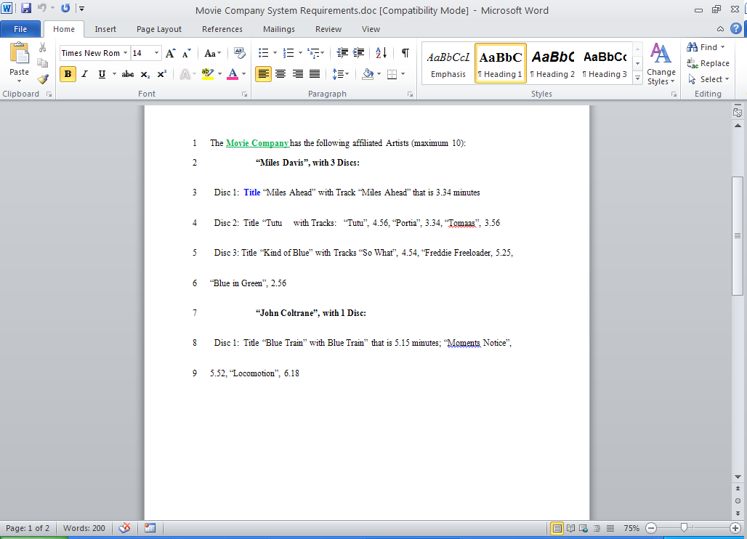

[0] [1] [2] …… [8] [9]
artists
:Artist
name = “Miles Davis”
name = ”John Coltrane”
:Artist

Catalog
-MAX_ARTISTS = 10 //1
-MAX_DISCS = 30 //2
- artists: Artist[MAX_ARTISTS] //3
- discs: Disc[MAX_DISCS] //4
#numberOfArtists: int //5
#numberOfDiscs: int //6
+ addArtist(String artist): void // 1
+ listArtists(): void // 2
+ addDisc(String artistName, String discCatalogNumber, String discTitle): void // 3
+ listDiscs(): void // 4
+ addTrack(String discCatalogNumber, String trackTitle, double time): void // 5
+ listTracksForDisc(String discCatalogNumber): void // 6
+ restoreCatalog(): void // 7
+ saveCatalog(): void // 8

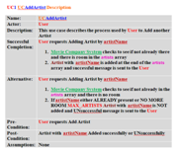
public void addArtist(String artistName){
If the artistName is not already in the catalog
if (numberOfArtists < MAX_ARTISTS)
artists[numberOfArtists] = new Artist(artistName);
numberOfArtists++;
} // 1

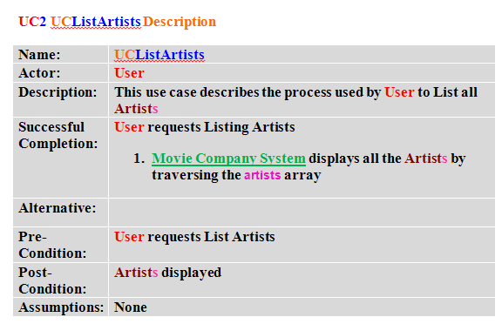

public void listArtists(){
for (int i=0;i<numberOfArtists;i++)
display artists[i].getName());
} // 2

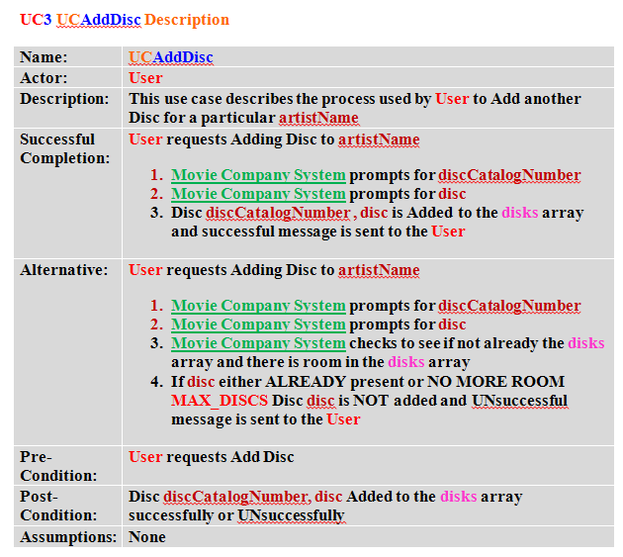

public void addDisc(String artistName, String discCatalogNumber, String discTitle){
get the artist for artistName Artist result = getArtistForName(artistName);
create a new Disc object Disc theDisc = new Disc(result, discCatalogNumber, discTitle);

if (numberOfDiscs < MAX_DISCS)
discs[numberOfDiscs] = theDisc;
numberOfDiscs++;
} // 3

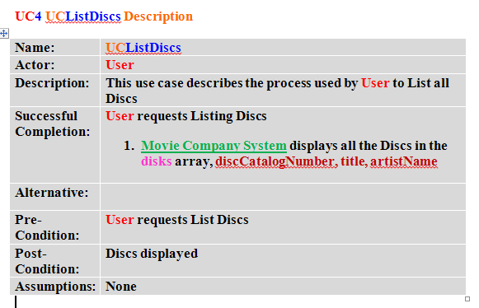
public void listDiscs(){
for (int i=0;i<numberOfDiscs;i++)
display discs[i].getDiskCatalogNumber() + ", "
+ discs[i].getTitle() + ", by "
+ discs[i].getArtist().getName()
} // 4

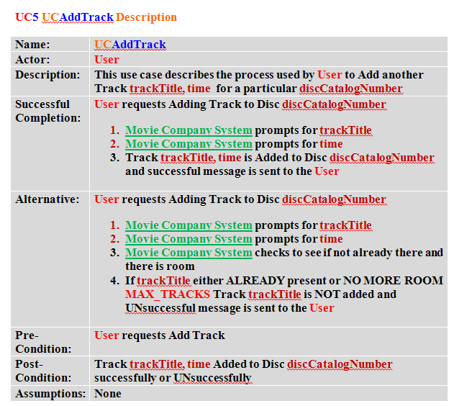
public void addTrack(String discCatalogNumber, String trackTitle, double time){
get the disc for discCatalogNumber Disc result = getDiscForCatalogNumber(discCatalogNumber);
if (result.getNumberofTracks() < Disc.MAX_TRACKS)
Track theTrack = new Track(trackTitle, time);
result.addTrack(theTrack);
} // 5

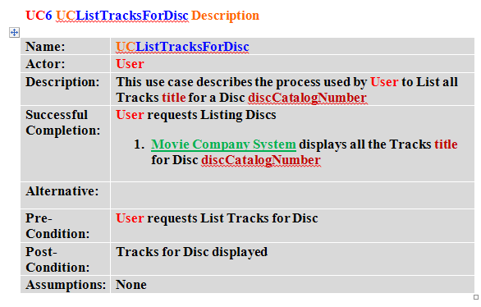
public void listTracksForDisc(String discCatalogNumber){
get the disc for discCatalogNumber Disc result = getDiscForCatalogNumber(discCatalogNumber);
for (int i=0;i<result.getNumberofTracks();i++)
display result.getTrack(i).getTitle());
} // 6

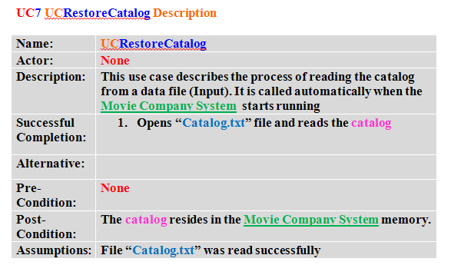
public void restoreCatalog(){
Catalog catalog = new Catalog();
catalog.artists = artists;
catalog.discs = discs;

open file to write File file = new File("Catalog.txt");

out.writeObject(catalog);
} // 7

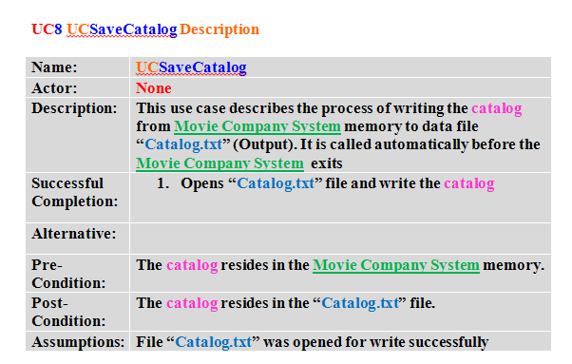
public void saveCatalog(){

open file to read File file = new File("Catalog.txt");
catalog = (Catalog)in.readObject();

artists = catalog.artists;
discs = catalog.discs;

// set number of artists and discs
while (artists[numberOfArtists] != null)
numberOfArtists++;

while (discs[numberOfDiscs] != null)
numberOfDiscs++;
} // 8
// UTILITIES //
/**
* getArtistForName() : Artist - returns an Artist object for
* a specified artist name
*
* @param name string containing the
* name of an Artist
* @return the Artist object
* with the specified name
*/
private Artist getArtistForName(String name) {

int i = 0;
int found = 0;
while (i<numberOfArtists && found==0)
{
compare the names if (name.compareTo(artists[i].getName()) == 0)
found = 1;
i++;
}
if (found == 1)
return the Artist object return artists[i-1];
else return
null;
}
/**
* getDiscForCatalogNumber() - returns a Disc object for
* a specified catalog number
*
* @param discCatalogNumber string containing
* the catalog number of a disc
* @return the Disc object with the specified name
*/
private Disc getDiscForCatalogNumber(String discCatalogNumber)
{
int i = 0;
int found = 0;
while (i<numberOfDiscs && found==0)
{
compare the discCatalogNumbers
if (discCatalogNumber.compareTo(discs[i].getDiskCatalogNumber()) == 0)
found = 1;
i++;
}
if (found == 1)
return the Disc object return discs[i-1];
else
return null;
}

